Problem Solving Process

Class 8
Lab 7

Lab Objectives:

Problem solving strategies
- Knowing your power

Introduction

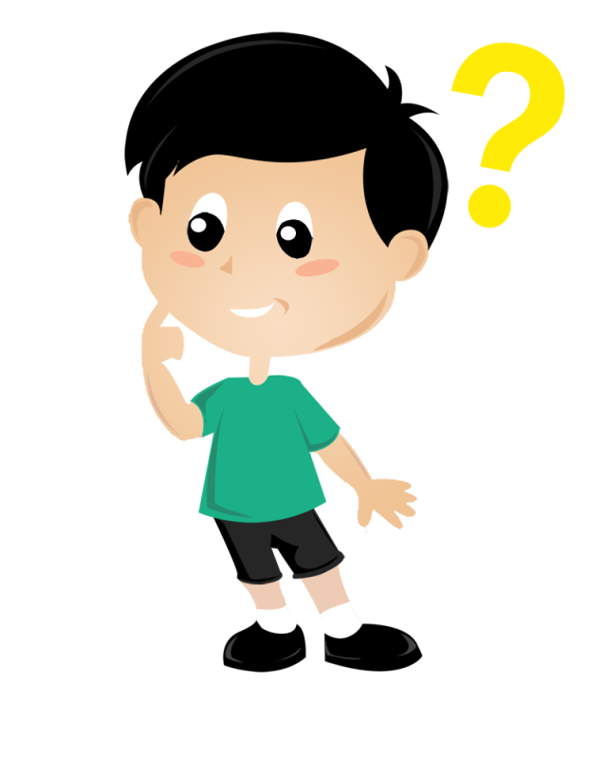
There are three forms of applied thinking that we all need:

decision making,

problem solving and

creative thinking.

Decision making is about deciding what action to take; it usually involves choice between options. The object of problem solving is usually a solution, answer or conclusion. The outcome of creative thinking, by contrast, is new ideas.

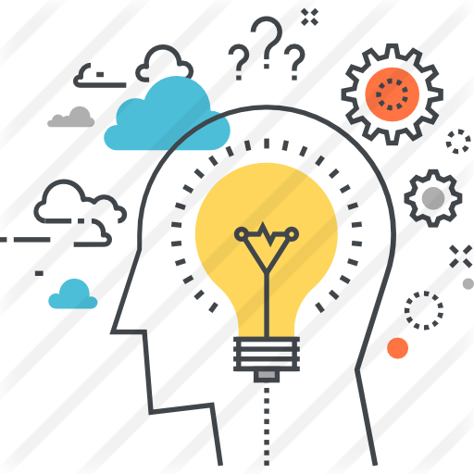

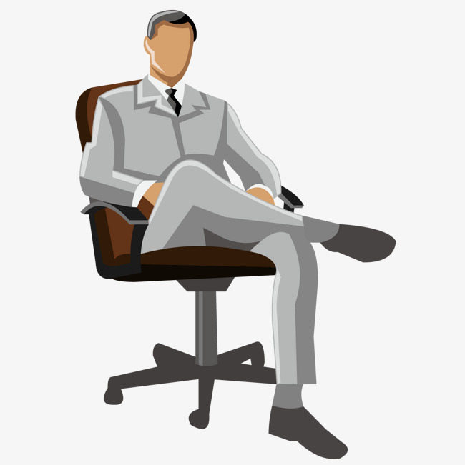
Any leader such as yourself who aspires to excellence obviously has a vested interest in seeing that the best decisions are taken, that problems are solved in the optimum way and that the creative ideas and innovations so necessary for tomorrow’s business flow freely.

Of course, everyone in the team or organization should be engaged in meeting these essential requirements. But you are the one who is called to provide the intellectual leadership that is needed. Are you willing to do so?
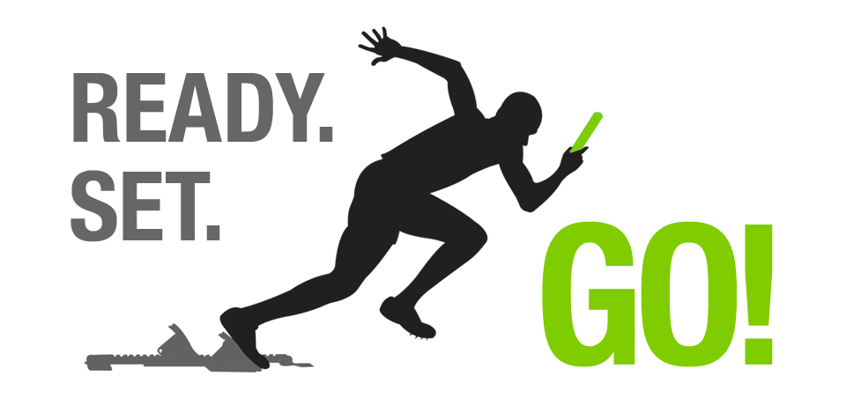

One step towards that end that you should definitely take is to become master of the processes of practical thinking,the processes that lie behind all effective decision making, problem solving and creative thinking.

You cannot guarantee outcomes – for luck or chance plays a part in all human affairs – but you can at least make sure that you use the well tried-and-tested processes of thinking to some purpose.

The key purpose of the course Problem Solving Process are:

• understand the way in which the mind works and the principles of effective thinking;

• have a clear framework for decision making;

• be aware of the relation between decision making and problem solving;

• be able to use a unified model for both making decisions and solving problems;

• have sharpened up your creative thinking skills;

• be in a position to chart a way forwards for improving your thinking skills across the board.

All you have to know is to
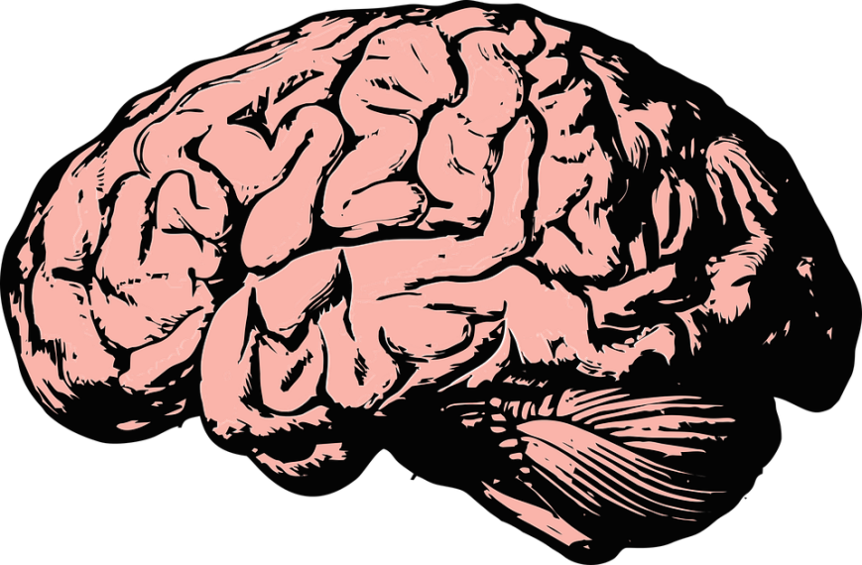

Use It

Your mind at work

Behind your practical, everyday thinking there lies the most complex thing in the known universe: the human mind. Nobody hires and pays you nowadays for your physical strength. You are employed because you have a mind – and can use it effectively.

There is a vital distinction between brain and mind. Take a computer as an analogy. Your brain is what you see if you open up the back of the computer – all those chips and circuits –whereas the mind is what appears dynamically on the screen. In this book we are focusing on the mind, for that is accessible to us without peering into the skull.

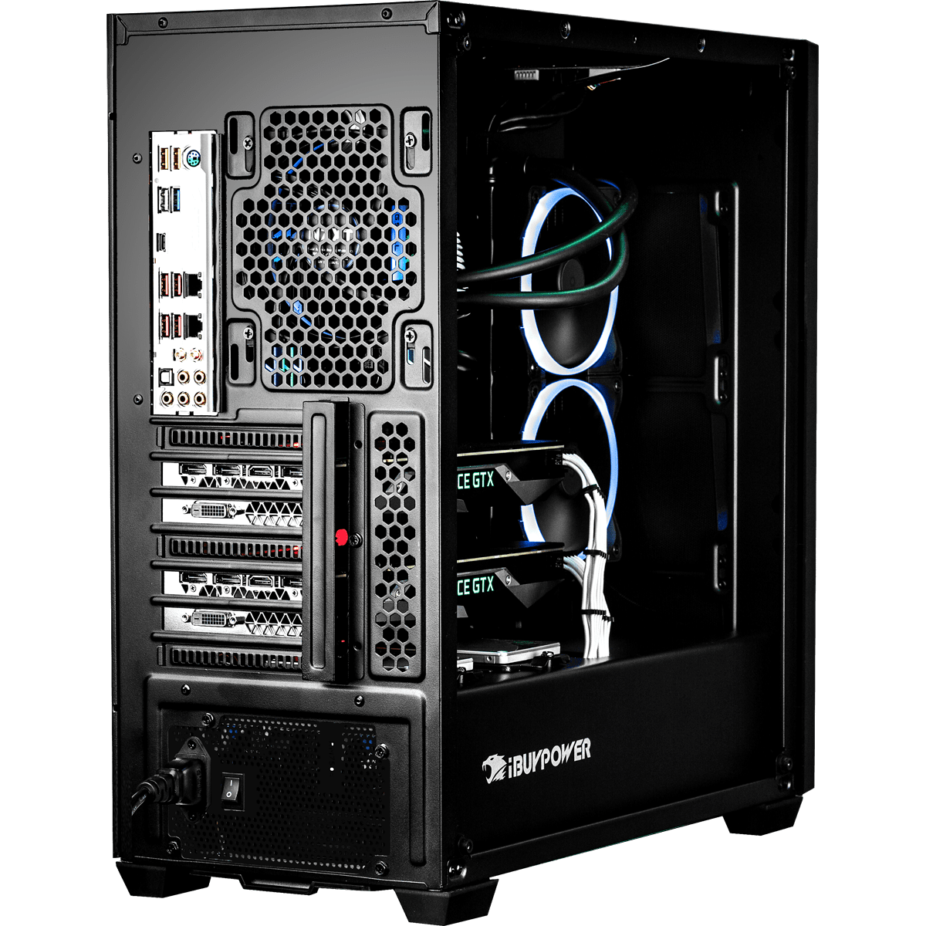

Is your brain working now?

The physical base of your mind is of course your brain, the grey matter housed in your head. Your brain is composed of about 10,000 million cells. In fact it has more cells than there are people on the face of the earth! Each one of those cells can linkup with approximately 10,000 of its neighbours, which gives you some 1 plus 800 noughts of possible combinations.

Our potential brain power is known to be far greater than the actual power it achieves. No one has remotely approached the limits of it. One estimate suggests that we use no more than about 10 per cent of our brain power. So don’t be worried by the fact that you are losing about 400 brain cells every day – indeed, if you do not exercise your mind throughout your life your brain will shrink at a faster rate.
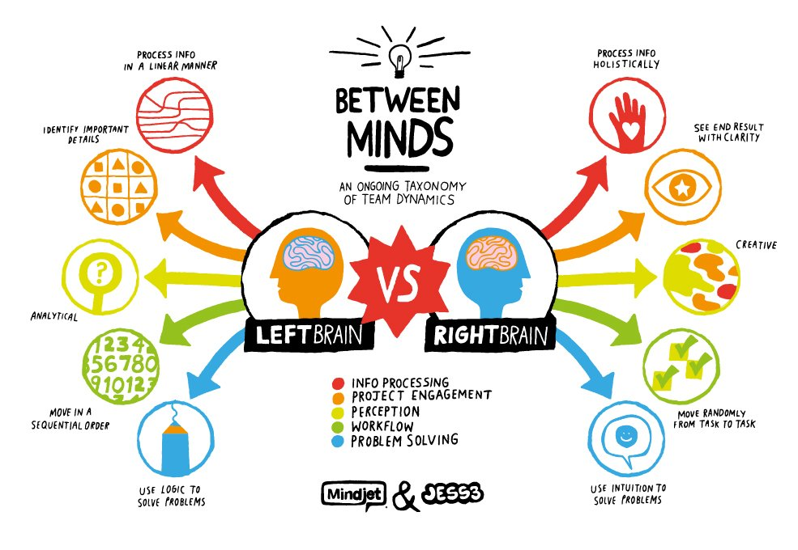

Use it or lose it! Before we go any further, I suggest we double-check that all your 10,000 million brain cells are warmed up and working properly by trying to solve some problems.
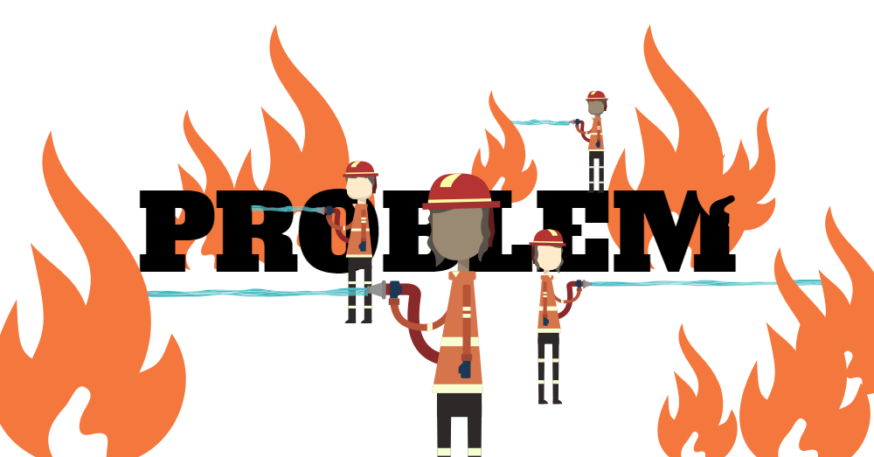

Actually, the three problems below require only about 3,000 million brain cells, so they will not take long or cause us much delay! Two other points before we begin. The three problems are not just brain-teasers: they illustrate principles about thinking.

Problem 1: The nine dots

Take a piece of paper larger than this page and put on it a pattern of nine dots, like this:
● ● ●
● ● ●
● ● ●

Now connect up the dots by four straight consecutive lines (that is, without taking your pen or pencil off the paper). You should be able to complete this task within three minutes.

Problem 2: The six matchsticks

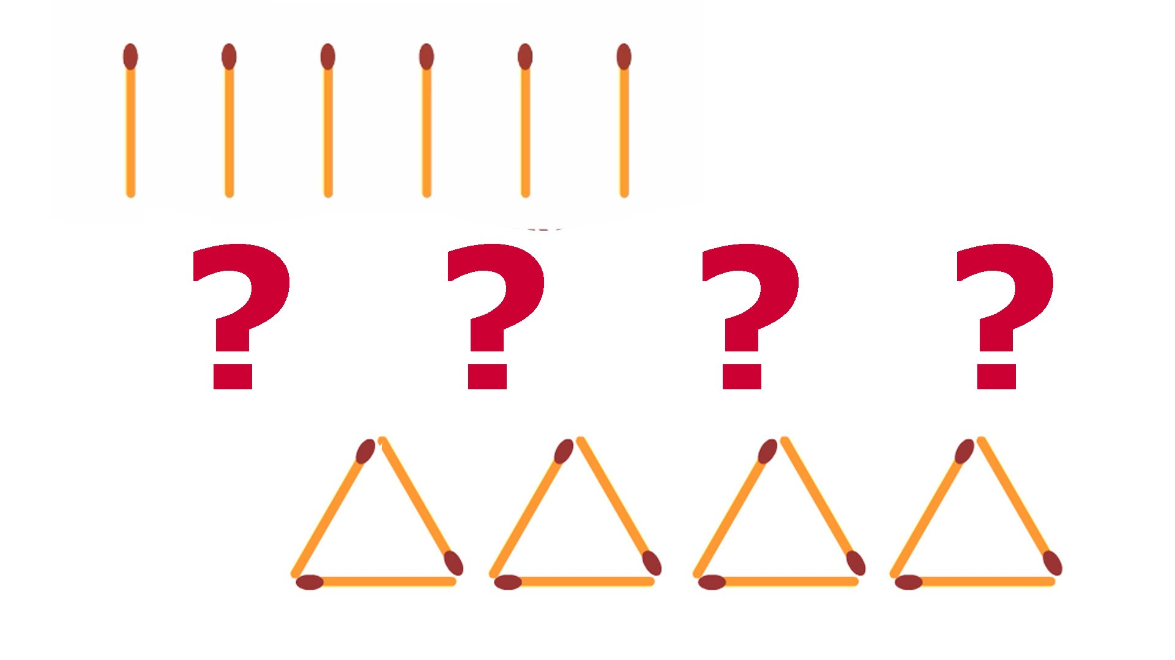
Place six matchsticks – preferably of the wooden variety – on a flat surface. Now arrange the matchsticks in a pattern of four equilateral (ie equal-sided) triangles. You may not break the matchsticks – that is the only rule. Again, you should be able to do it within three minutes. There are at least two solutions, but we want the best one.

Problem 3: Who owns the zebra?

Having got the two easy ones safely behind you – well done if you have solved both those problems – we come now to something

a little more demanding, so you must call up your reserve brain
cells.

The world record for solving both parts of this problem is 10 minutes. So I will give you 30 minutes which, I am sure you will agree, is overgenerous of me!

There are five houses, each with a front door of a different colour, and inhabited by people of different nationalities, with different pets and drinks. Each person eats a different kind of food.

The Australian lives in the house with the red door.

The Italian owns the dog.

Coffee is drunk in the house with the green door.

The Ukrainian drinks tea.

The house with the green door is immediately to the right (your right) of the house with the ivory door.

The mushroom-eater owns snails.

Apples are eaten in the house with the yellow door.

Milk is drunk in the middle house.

The Norwegian lives in the first house on the left.

The person who eats onions lives in the house next to the person with the fox.

Apples are eaten in the house next to the house where the horse is kept.

The cake-eater drinks orange juice.

The Japanese eats bananas.

The Norwegian lives next to the house with the blue door.

Now, who drinks water and who owns the zebra ?
